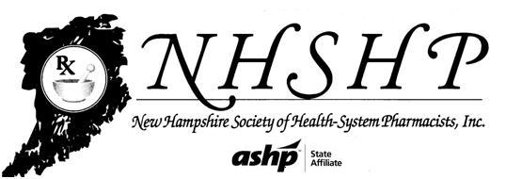
Strategic Plan 2015-2020
NHSHP Mission
To advance patient outcomes by promoting the professional interests of pharmacists, pharmacy technicians, pharmacy residents, and pharmacy students, practicing in settings spanning the full spectrum of medication use.

Priorities and Goals for 2015-2020
Patient Care
- Advance pharmacy practice in all medication use settings in New Hampshire.
- Support the continued competence of pharmacists, pharmacy technicians, residents, and students, through the provision of contemporary professional development.
- Advocate for changes in laws, regulations, and standards that will improve patient care.
Membership
- Maintain a high level of member satisfaction and engagement.
- Grow NHSHP membership.
Organization
- Develop and maintain a sustainable financial plan.
- Maintain effective and energized governance.
- Effectively manage organizational infrastructure.

Objectives
Advance pharmacy practice in all medication use settings in New Hampshire.
Support the continued competence of pharmacists, pharmacy technicians, residents, and students, through the provision of contemporary professional development.
Advocate for changes in laws, regulations, and standards that will improve patient care.
Maintain a high level of member satisfaction and engagement.
Grow NHSHP membership.
Develop and maintain a sustainable financial plan.
Maintain effective and energized governance.
Effectively manage organizational infrastructure.

Goals:
Written policies
Yearly budget
Financial growth
Evaluate Board size
Define roles of Board members
Orientation of new members
Assessment of meetings
Increase membership base

